**HealthGrid ADT Requirements**

**2.1**

**Prepared By: Tiffany Bohall**

**Date: 11/29/2018**.

Document Control 3

Resources 3

Project Distribution List 3

Document Version Control 3

1. Introduction 4

1.1 Purpose 4

1.2 Project Scope 4

1.3 Terminology Standards 4

1.3.1 Acronyms 4

1.3.2 Glossary 4

1.4 Document References 4

2. Diagram 5

3. Requirements 6

3.1.1 Functional Requirements 6

3.1.3 Non-Functional Requirements 6

3.2 Messaging Protocols 6

3.2.1 Inbound to the BayCare Cloverleaf –N/A 6

3.2.2 Outbound from Cloverleaf for ADT 6

3.2.3 Outbound from the BayCare Cloverleaf for ORU’s –N/A 7

3.2.4 Inbound to the Vendor –*Same as outbound from Cloverleaf above* 7

3.2.5 Inbound from BayCare Cerner to Cloverleaf for ORU’s –N/A 7

3.2.6 Outbound from BayCare Cerner –N/A 7

4. HL7 Messaging 8

4.1 Messaging Format 8

4.1.1 Segments 8

4.1.2 Messaging Event Types 9

4.1*.*3 Cloverleaf Configuration Files 9

4.1.4 Colverleaf Site Location 9

4.2 Data Transformation Requirements –ADT 10

4.2.1 Nurses station room and bed 11

4.3 Sample Message 12

5. Testing 13

5.1 Unit Testing Scenarios 13

5.2 Integrated Testing Scenarios 13

5.3 Testing Approvals 13

5.4 Piloting 14

5.5 Approvals 14

6. Deployment / Implementation Model 14

Appendix A: Risks and Concerns –N/A 14

Appendix B: Issues List 15

# **Document Control**

## Resources

|  |  |  |
| --- | --- | --- |
| **Name** | **Role** | **Email** |
| Thomas Hawley | BayCare Project Manager | Thomas.Hawley@baycare.org |
| Nicholas Raia | BayCare Project Manager | Nicholas.Raia@baycare.org |
| Tiffany Bohall | BayCare Integration Analyst | Tiffany.Bohall@BayCare.org |
| Tony McArtor | BayCare Integration Analyst | [Tony.McArtor@baycare.org](mailto:Tony.McArtor@baycare.org) |
| Heather Morrison | Systems Analyst Sr. | Heather.Morrison@baycare.org |
| Edward Holden | Systems Analyst | Edward.Holden@baycare.org |
| Carmen LaBrecque | Systems Analyst Sr. | Carmen.LaBrecque@baycare.org |
|  |  |  |

## Project Distribution List

## Document Version Control

|  |  |  |  |
| --- | --- | --- | --- |
| **Version** | **Date** | **Modifier** | **Description** |
| V1.0 | 05/20/2015 | Tony McArtor | Originally Created |
| V2.0 | 07/06/2015 | Tiffany Bohall | Updated to include what was taking place in Cloverleaf |
| V2.0 | 12/29/16 | Tiffany Bohall | Separated ADT from the ORU requirements |
| V2.1 | 11/29/2018 | Tiffany Bohall | Modified facility filter to allow ISU and SIP Behavioral Health locations |
|  |  |  |  |

# 1. Introduction

## 1.1 Purpose

This document outlines BayCare’s Healthgrids interfaces. All functional requirements needed to support this solution post implementation will be detailed.

## 1.2 Project Scope

The HealthGrid application interface enables secure transmission of patiet information to their chosen cell devices. This is a device-agnostic mobile solution that updates patients and families with real-time information about their important clinical events. Patients are given access to their discharge instructions in real-time on their mobile device.

## 1.3 Terminology Standards

### 1.3.1 Acronyms

MLLP – Minimum Lower Layer Protocol for messaging framing a HL7 message.

### 1.3.2 Glossary

## 1.4 Document References

List all documents or Web addresses to which this IDBB refers; provide enough information so that the reader can access a copy of each reference. Include the title, author, version number, date, and source or location.

**HealthGrid Specifications:** HealthGrid_InterfaceSpecificatioDocument.pdf

# 2. Diagram

The solution diagram that depicts the integration of components specified in this IDBB is below. This diagram includes two interfaces ADT and ORU datafows. The red box illustrated the ADT interface and the blue box represents the ORU interface.

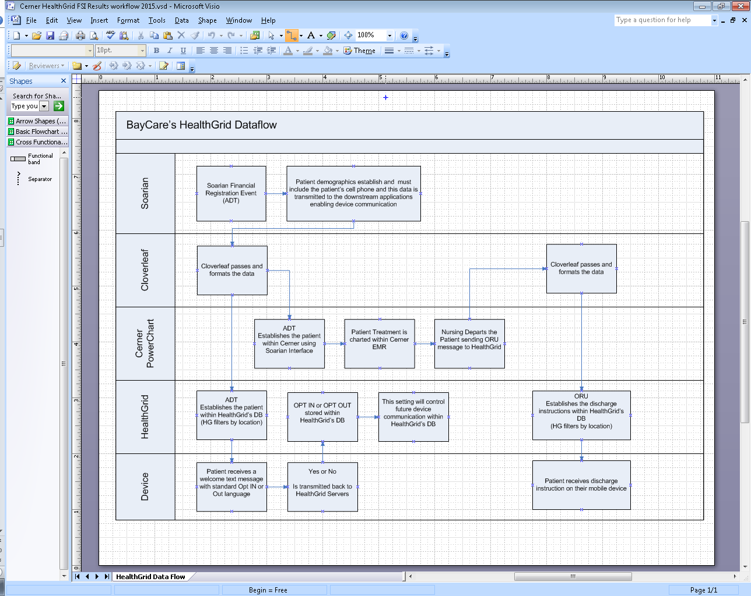

# 3. Requirements

## 3.1.1 Functional Requirements

|  |  |  |  |
| --- | --- | --- | --- |
| **Cloverleaf** |  |  | |
| **Number** | **Requirement Name** | **Requirement Description** | |
|  |  |  | |
| FR.2015.07.06 | Cell phone numbers | HealthGrid can only communicate with patients as long as the cell phone number is collected on the front end; in PID.13, with phone use code of “ORN CP” from Soarian | |
|  |  |  | |
|  |  |  |

## 3.1.3 Non-Functional Requirements

|  |  |  |
| --- | --- | --- |
| **Cloverleaf** |  |  |
| **Number** | **Requirement Name** | **Requirement Description** |
| NFR.2015.07.06 | Age restrictions | Due to Florida law, HealthGrid was requested to filter communication with children between the age ranges 12-17. |

## 3.2 Messaging Protocols

Below are listed the details for the messaging protocols that will be leveraged for this integration. Please see the reference document located on the Integration SharePoint server: <insert link to document here>

### 3.2.1 Inbound to the BayCare Cloverleaf –N/A

### 3.2.2 Outbound from Cloverleaf for ADT

**Test**

Port Number: 5070

IP Address: 10.44.142.186

**Prod**

Port Number: 5070

IP Address: 10.44.99.190

### 3.2.3 Outbound from the BayCare Cloverleaf for ORU’s –N/A

**Test**

Port Number:

IP Address:

**Prod**

Port Number:

IP Address:

### 3.2.4 Inbound to the Vendor –*Same as outbound from Cloverleaf above*

### 3.2.5 Inbound from BayCare Cerner to Cloverleaf for ORU’s –N/A

**Test**

Port Number:

IP Address:

**Prod**

Port Number:

IP Address:

### 3.2.6 Outbound from BayCare Cerner –N/A

# 4. HL7 Messaging

## 4.1 Messaging Format

The formatting of these messages from an ADT perspective are only sent through the Soarian normalize translation proc. Outside of modifications made in that translation only, the messages are then sent outbound to HealthGrid raw, with no additional modifications specific to HealthGrid.

### 4.1.1 Segments

The segments utilized for this interface are:

MSH

[ZSH]

[EVN]

PID

[PD1]

[MRG]

[{NK1}]

[PV1]

[PV2]

[{ROL}]

[{OBX}]

[{DG1}]

[{DRG}]

[{PR1}]

[{GT1}]

[ZG1]

[{

IN1

[IN2]

[ZIN]

[ZAR]

[{PRT}]

}]

[PDA]

[ZPV]

[ZP1]

[{ZPT}]

[ZID]

*Message Construction Notes:*

*[Square Brackets] – Optional*

*{Curly Brackets} – Repeatable*

*MSH – Message Header*

*EVN – Event segment*

*PID – Patient ID segment*

*PV1 – Patient Visit segment*

*ORC – Common Order segment*

*IN1 – Insurance segment*

*[{ – Start of optional, repeatable group*

*}] – End of optional, repeatable group*

### 4.1.2 Messaging Event Types

Below are the messages types necessary for this integration

|  |  |
| --- | --- |
| **Event Type** | **Description** |
| A01 | Inpatient Admit |
| A03 | Discharge transaction |
| A04 | ER / OP arrival |
| A08 | Update patient information |

### 4.1*.*3 Cloverleaf Configuration Files

**ADT**

* Variants: HL7 v2.6, Soarian ADT_A01
* TCL Scripts: N/A
* Xlates: soarf_adt_norm

### 4.1.4 Colverleaf Site Location

Cloverleaf site location: hlthgrid_27_p

## 4.2 Data Transformation Requirements –ADT

|  |  |  |  |  |  |
| --- | --- | --- | --- | --- | --- |
| **Field Description** | **HL7 Field Loc.** | **Required Y/N** | **Data Type** | **Length** | **Notes** |
| Sending facility | MSH:4 | Y | HD | 227 | Convert facility from hospital/ region format to 3 character format using soarf_facility_codes table |
| Patient Identifier List | PID.3 | Y | CX | 250 | Extract the CPI, MRN and SSN from PID.3 and verify ID’s are not expired. Order the values back into PID.3 and identify each |
| Patient Account Number; assigning authority | PID.18.3 | Y | CX | 250 | Convert facility from hospital/ region format to 3 character format using soarf_facility_codes table |
| Patient Type | PV1.18 | Y | CX | 250 | Determine patient class “E”, if PV1.18 = “ER” |
| Attending Physician  Admitting Physician | PV1.7  PV1.17 | Y  Y | XCN  XCN | 250  250 | Extract physician name, MS nbr, NPI nbr, PRDOC nbr and onecall indicator. Order these values back into PV1.7/PV1.17 and identify each |
| PCP | ROL.4 | Y | XCV | 250 | Extract physician name, MS nbr, NPI nbr and PRDOC nbr. Order these values back into ROL.4 and identify each |
| Patient location  Prior patient location | PV1.3  PV1.6 | Y | PL  PL | 80  80 | Modify the nurse station, room and bed from Soarian into a format similar to the Invision format.  ***Code below in section 4.2.1*** |
| Patient Type | PV1.18 | Y | IS | 10 | Use the encounter provider in PV2.23.2 to derive the patient type from a table.  If the PV2.24 patient status code is “Scheduled” derive an IP or OP patient type |
| Discharge Disposition | PV1.36 | Y | IS | 3 | Derive a discharge disposition for one-time outpatients and recurring patients for HIM |
| Discharge Date/Time | PV1.45 | Y | DTM | 24 | Default 23:59 in discharge time field if not present on Soarian A03 discharge event |

### 4.2.1 Nurses station room and bed

Nurse station, room and bed logic performed in the Soarian normalization translation:

# SF3NP^SF301P^G301P02 - 3NP 301P 02

# SFPACH^SFPACHRM^GPACH02 - PACH PACH 02

# JHSRR^JHSRRRM^NSRR11 - SRR SRR 11

set nstn [lindex $xlateInVals 0]

set room [lindex $xlateInVals 1]

set bed [lindex $xlateInVals 2]

echo "nstn $nstn"

echo "room $room"

echo "bed $bed"

# remove facility ID from nurse station (JH)

set nstn [string range $nstn 2 end]

echo "remove JH nstn $nstn"

# remove facility ID from room (JH)

set room [string range $room 2 end]

echo "remove JH room $room"

# remove RM from room if it exists

set indx ""

set indx [string first "RM" $room]

echo "remove RM indx $indx"

# if RM exists in room calculate a new room length without RM

if {![string equal $indx "-1"]} {

set roomlen [string length $room]

echo "room length before remove RM $roomlen"

set roomlen [expr $roomlen - 2]

echo "room length recalculated without RM $roomlen"

# strip the RM from the room

set room [string range $room 0 [expr $roomlen - 1]]

echo "new room code to remove RM executed $room"

}

# remove the first character from the bed (N)

set bed [string range $bed 1 end]

echo "removed first char from bed $bed"

# get the room length

set roomlen [string length $room]

echo "get room length roomlen $roomlen"

# remove the room from the bed field leaving the bed

set bed [string range $bed $roomlen end]

echo "removed room leaving bed $bed"

set xlateOutVals [list $nstn $room $bed]

echo "final $nstn $room $bed"

## 4.3 Sample Message

MSH|^~\&|SOARF|SJW|||201507061317||ADT^A04|bea48b03-593e-4c46-8ac7-8d8c191d8646|P|2.7||1

EVN|A04|201507061317||CI|aji81372|201503191911|9070

PID|1|300140043^^^900000^PN|2104711175^^^BCHS^MR||DEFANT^YVONNE^^^^^L^^^20150706||19830308|F||White|7744 CITRUS BLOSSOM DR^""^Land O Lakes^FL^34637^USA^M^^Pasco^^^20150706||||EN|M|Christian|6000000308^^^BCHS^VCD^^20150706||||Non HIS or LAT||N|0|||||N|N

PD1||||||||N

PV1|1|E||Emergency|||666666^Unassigned^ER Doctor^^^PRN^^^66666^PRDOC^SJW|||ERD|||N|EO|||666666^Unassigned^ER Doctor^^^PRN^^^66666^PRDOC^SJW|E|5100119477^^^504^VN^^20150706|HMO|||||||||||||||||||9070|||||201503191911|||||||V

PV2|||^ICD-10 TESTING||||~~~~false||||||0||N||||||N||JW ED Svcs^L^2171^^^900000^XX~^^1346519816^^^900004^NPI~^^590774199^^^900001^TX|Checked in|||||||N|||||N||W

ROL||AD|PP|555555^No^PCP per pt^^^PRN^^^55555^PRDOC^SJW|201507061314||||Phys

ROL||AD|AT|66666^Unassigned^ER Doctor^^^^^^1316^L^^^PRN^^^^20140211~66666^^^^^^^^1325^^^^PRN~66666^^^^^^^^581^^^^PRN~66666^^^^^^^^2077^^^^PRN~66666^^^^^^^^2075^^^^PRN~66666^^^^^^^^2076^^^^PRN~66666^^^^^^^^1505^^^^PRN~66666^^^^^^^^2078^^^^PRN~01673^^^^^^^^684^^^^PRN~01673^^^^^^^^737^^^^PRN~269^^^^^^^^900000^^^^DN~666666^^^^^^^^183^^^^PRN|201503191911||||Phys

ROL||AD|AD|66666^Unassigned^ER Doctor^^^^^^1316^L^^^PRN^^^^20140211~66666^^^^^^^^1325^^^^PRN~66666^^^^^^^^581^^^^PRN~66666^^^^^^^^2077^^^^PRN~66666^^^^^^^^2075^^^^PRN~66666^^^^^^^^2076^^^^PRN~66666^^^^^^^^1505^^^^PRN~66666^^^^^^^^2078^^^^PRN~01673^^^^^^^^684^^^^PRN~01673^^^^^^^^737^^^^PRN~269^^^^^^^^900000^^^^DN~666666^^^^^^^^183^^^^PRN|201503191911||||Phys

OBX|1|CE|2PCPFAX^^LSFUSERDATAE||N||||||R

OBX|2|CE|AdditionalData1^^LSFUSERDATAE||N||||||R

OBX|3|NM|9272-6^Apgar 1^LN||0

OBX|4|NM|9274-2^Apgar 5^LN||0

GT1|1|2104711175^^^504^MR^^20150706~300140043^^^900000^PN^^20150706|DEFANT^YVONNE^^^^^L^^^20150706||7744 CITRUS BLOSSOM DR^""^Land O Lakes^FL^34637^USA^M^^Pasco^^^20150706|||19830308|F|P|6||||||||||||||N|||||M||||||EN|||||Christian|||Non HIS or LAT|||||||||||White

IN1|1|1665^Humana HumX|425^^^900000^XX^^20120228~611041514^^^900001^TX^^20140328~NLU00007^^^184^CRI^^20140328|Humana^L^425^^^900000^XX|PO Box 14635^^Lexington^KY^405124635^USA^M^^^^POLCS-M|^^^^^^^POLCS-M|^NET^^^^^^^POLCS-M|R7646001|Humana HumX||||||Health|DEFANT^YVONNE^^^^^L^^^20150706|6|19830308|7744 CITRUS BLOSSOM DR^""^Land O Lakes^FL^34637^USA^M^^Pasco|||1|||||||20150706|||||||H55719598|||||||F||true||||2104711175^^^504^MR^^20150706~300140043^^^900000^PN^^20150706

IN2|||||||||||||||||||||||||99999|GENE||||||||EN|||||Christian|||Non HIS or LAT|M||||||||||||||||||||||||||||White|6

ZIN||||||||||||||||||||||||||||||||||||||||||||||||||||^^policyPlanName^policyPlanName^Humana HumX||||||HMO^^^183^NHPI^20140312~1665^^^900000^HPI^20140312

PDA||||||N|||N

ZPV|||||||||||||||||||||||||||||||||||||||||||||||||""||||||||||||^^mostCurrEncTypeCd^mostCurrEncTypeCd^OP||||||||5100119477^^No SCD^504^ZAVN^^20150706||201503191911

# 5. Testing

## 5.1 Unit Testing Scenarios

|  |  |
| --- | --- |
| **Scenario** | **Expected Result** |
| ADT message sent to HealthGRid | Text messages sent to customers phones |
|  |  |
|  |  |
|  |  |
|  |  |

## 5.2 Integrated Testing Scenarios

|  |  |
| --- | --- |
| **Scenario** | **Expected Result** |
| ADT message sent to HealthGRid for all facilities | Text messages sent to customers phones |
|  |  |
|  |  |
|  |  |
|  |  |
|  |  |

## 5.3 Testing Approvals

|  |  |  |  |
| --- | --- | --- | --- |
| **Testing Phase** | **Date** | **Department** | **Team Member** |
| PH1.UNIT |  |  | Heather Morrison |
| PH1.INTEGRATED |  |  | Heather Morrison |

### 

## 5.4 Piloting

The first piloted location was three nursing floors at St Joseph’s Children’s Hospital. Once this was completed filters were removed and all of Joseph’s Hospital were included. The project is now moving toward adding all hospital facilties located in hillsbourough county.

All Soarian facilities are sending data though, so when more facilities are brought online, there is no need to interface modifications

## 5.5 Approvals

|  |  |  |  |
| --- | --- | --- | --- |
| **Testing Phase** | **Date** | **Department** | **Team Member** |
| PH1.0 | 07/15/2015 | PowerChart | Heather Morrison |
| PH1.0 | 07/15/2015 | PowerChart | Edward Holden |
| PH1.0 | 07/15/2015 | RMS (Soarian) | Carmen LaBrecque |

# 6. Deployment / Implementation Model

The deployment of the healthgrid application will be by adding the inclusive filter to Healthgrid’s interface engine. BayCare is sending all facility messages (ADT & ORU) as of the 08/30/15.

## Appendix A: Risks and Concerns –N/A

|  |  |  |  |  |  |  |  |  |
| --- | --- | --- | --- | --- | --- | --- | --- | --- |
| **Project Name** |  |  | | |  |  |  |  |
| **Number** | **Risk / Concern** | **Comment** | **Mitigation** | | |  |  |  |
| RC.2015.1.0 |  |  | |  | |  |  |  |

## Appendix B: Issues List

This is a dynamic list of the open issues related to the IDBB that remain to be solved, including but not limited to TBDs, pending decisions, information needed, conflict awaiting resolution, and the like.

|  |  |  |  |  |  |  |  |  |
| --- | --- | --- | --- | --- | --- | --- | --- | --- |
| **Project Name** |  |  | | |  |  |  |  |
| **Number** | **Issue** | **Comment** | **Fix** | | |  |  |  |
| I.2015.7.6 | The interface stops receiving transactions | This has happened twice already, so far and we have been live since 6/24/15 | | We have changed port numbers and are using a new one now. Will continue to monitor. | |  |  |  |

* End of document